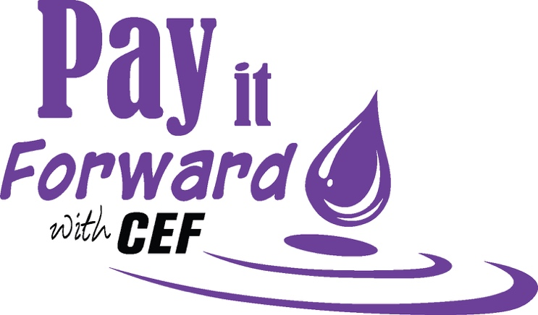
Sometimes, you can’t pay good deeds back;
you need to pay them forward.

Join your colleagues, friends and the
Cloquet Educational Foundation in support of education in Cloquet by “paying it forward”.
- WHO: All ISD #94 Staff

- WHAT: 2026-27 Annual Fund Drive benefiting quality education in Cloquet

- WHEN: September 28 – October 30, 2026

- WHERE: Please complete the form and “start a ripple” in Cloquet education today!
- Return completed form to the Cloquet Educational Foundation’s Office via interschool mail or email.

- WHY: Your tax-deductible donation will help support the many programs and initiatives of the Cloquet Educational Foundation in your school.

- Last year alone, we granted close to $100,000!

- Our goal is to inspire growth in the district through your generosity. Each gift, large or small, will ripple through the classrooms of our district in positive, impactful ways.

TAKE A LOOK AT SOME OF THE GRANTS FUNDED LAST YEAR!!

Canoe Mobile, Title One/AIE Family Events, Bringing Color Art Project, 2026 GAPP Trip to Germany,
CMS E-sports Team, CMS and CHS Student Council Events, All Night Grad Party,
Comfort and Care Activities, CMS Science Research/Monarch Butterfly Projects,
Band Commissions-Tonya Wind Singer, Broadway Tickets to Wicked for CHS New York Trip,
BRIDGE Fall Events, World Foods Project, Afterschool Club Projects,
TI-84 Calculators for 8th Grade, Safe and Strong Child Presentations, Kindness Programs, Knowledge Bowl, Spelling Bee, Literacy Nights, Activity Fee Support, Ripsaw Robotics, Family Science Night,
Trip to Spain, Power Lunch, UKE-can Make a Difference Music Program, Handheld Microscopes,
Ski Equipment, SOS Programs, Dramatic Play, Girls Flag Football, CAAEP Yearbooks, 7th Grade Literacy Circles, CMS Where Everyone Belongs (WEB) Program, 8th Grade Celebration,
Book Break Author Talks, Flexible Seating for ELL, CMS Garden, ROX @CMS,
Attendance Interventions, CAAEP Leadership Trip

You work hard every day to make a difference in the lives of Cloquet students. The Cloquet Educational Foundation joins you in that effort and is a community partner, champion, and resource for you. Throughout the year, we reach out to the community to raise funds for your classrooms. As board members share district needs, it is powerful for the community to learn that our district employees believe in the power of educational philanthropy and they, too, provide charitable donations.
The CEF reaches out to the community through the Invest In Kids Program, annual events, and other sources for support. We encourage our district employees to “Pay It Forward” through this Annual Fund Drive.

Name__________________________________________________  Address________________________________________________  City_____________________ State______________ Zip__________  School Building __________________________________________  CONTRIBUTOR’S  SIGNATURE_____________________________________________  Date__________________________ | 1 | PAYROLL DEDUCTION  I authorize my employer to deduct $_____ per paycheck for _____ pay periods Reminder, there are two paychecks per month ending June 30, 2027. 16 paychecks total.  TOTAL PLEDGE $________
 | 2  3 | CASH OR CHECK  AMOUNT $___________  PAYPAL AMOUNT $__  See our website,  cloquetedfoundation.org    or QR Code
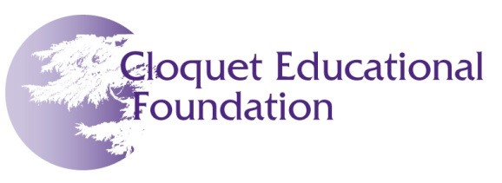
Please return completed form to the CEF office by October 30.
Our many thanks in advance for your support!
Please return to:

Cloquet Educational Foundation
302 14th Street
Cloquet, MN 55720
QUESTIONS? Contact the Cloquet Educational Foundation office:
Karrie Osvold
kosvold@isd94.org
218-879-6721 ext. 6221

